

Name: Hania Safdar

Intern ID: TN/IN02/PY/011

Email: [Haniasafdar290@gmail.com](mailto:Haniasafdar290@gmail.com)

Task Week: 1

Internship Domain: Python development

**TASK NO:1**

**STEP BY STEP:**

1. Input: The user is prompted to enter 3 numbers.

2. Conversion: Each input is converted from string to float for decimal support.

3. Calculation: The three numbers are added and divided by 3 to compute the average.

4. Output: The average is printed with a label average=.

**CODE:**

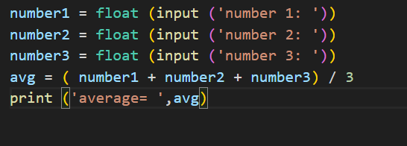

**OUTPUT:**

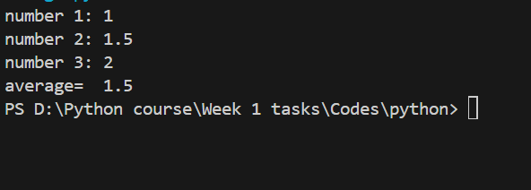

**LEARNED:**

I learned how to take input in Python using input(), convert it to a number with float(), and do basic math like finding the average. I also saw that Python doesn’t need data types for variables and uses simple print() to show output. The syntax is cleaner than Java or C++, and no semicolons or curly braces are needed.

**TASK NO:2**

**STEP BY STEP:**

1. I entered my weight and height.

2. Python converted both to float numbers.

3. It calculated BMI using the formula: weight ÷ (height squared).

4. It printed the result with the label BMI:.

**CODE:**

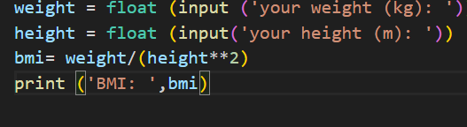

**OUTPUT:**

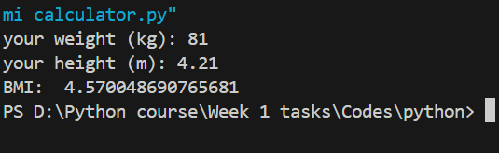

**LEARNED:**

I learned how to take user input for weight and height, convert them to numbers, and calculate BMI using the ** operator for squaring. I saw how easy it is to write math formulas and print results in Python compared to Java or C++.

**TASK NO:3**

**STEP BY STEP:**

1. I used a loop to keep showing the menu until I stop the program myself.

2. I entered a choice to pick between length, weight, or temperature conversion.

3. For each type, I entered another choice to select the direction of conversion.

4. I typed a number, and Python calculated the result using the right formula.

5. It printed the converted value. If I entered something wrong, it showed "invalid option".

**CODE:**

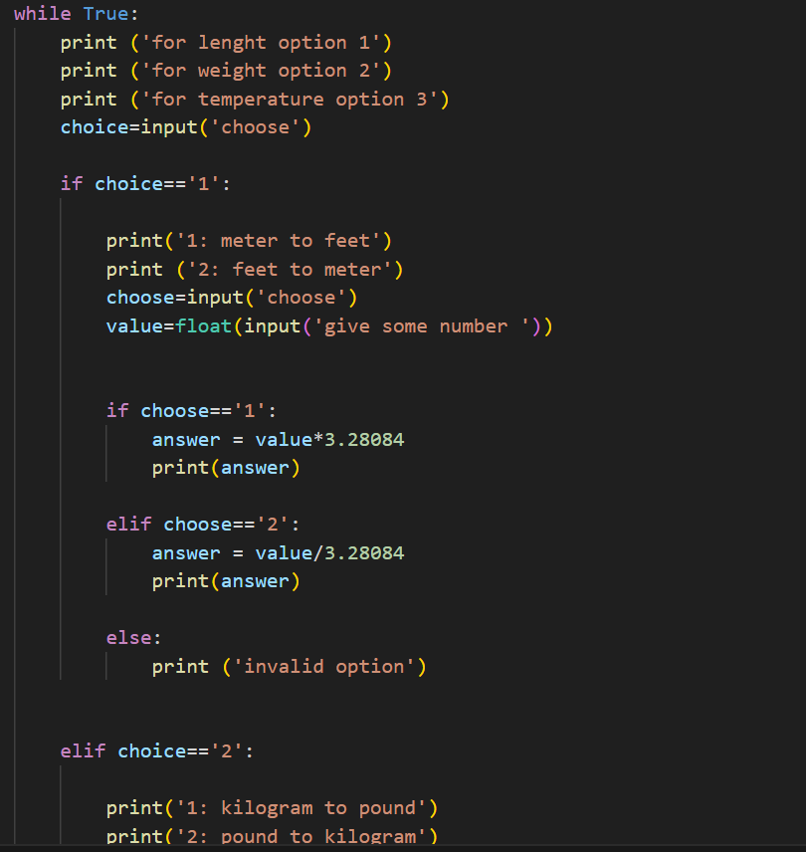

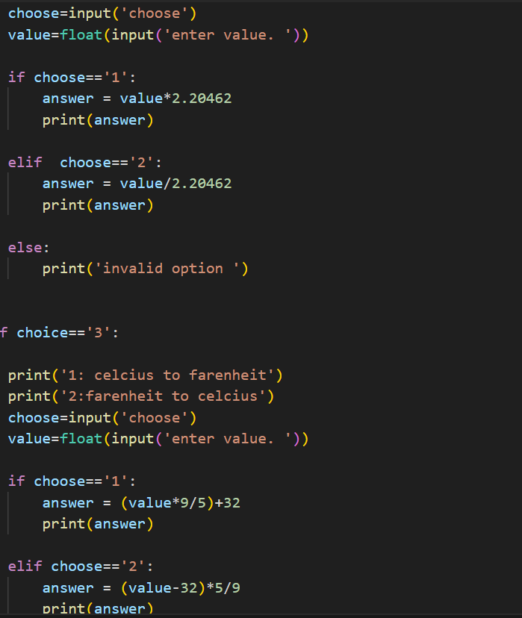

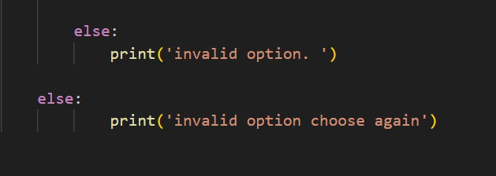

**OUTPUT:**

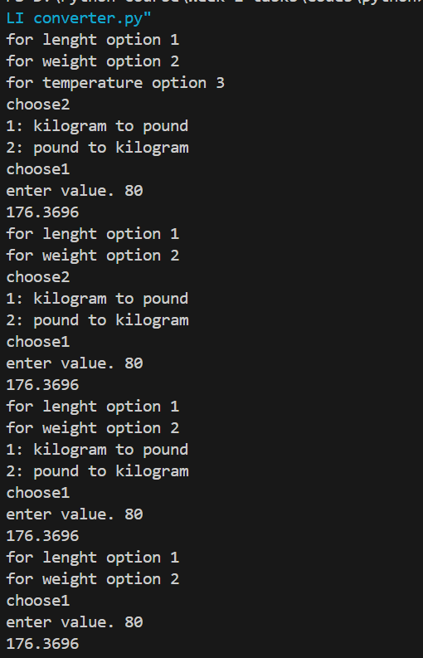

**LEARNED:**

I learned how to use while True to make a repeating menu, if-elif to handle different choices, and simple math for unit conversions. I also practiced using input() and float() again.

**TASK NO:4**

**STEP BY STEP:**

1. I entered a number, and Python converted it to an integer using int().

2. It checked if the number is divisible by 2 using the % operator.

3. If it was, it printed “It's even”.

4. If not, it printed “It's odd”.

**CODE:**

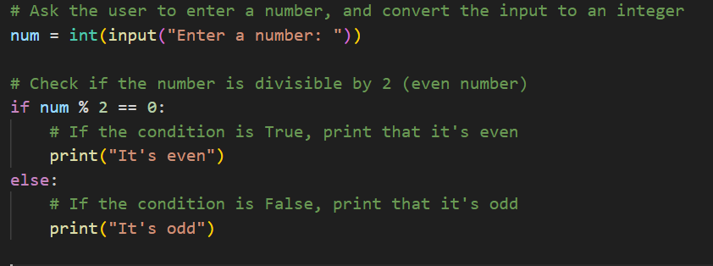

**OUTPUT:**

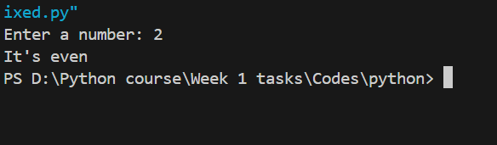

**LEARNED:**

I learned how to take integer input, use the modulus operator to check for even or odd numbers, and use if-else to control what gets printed.

**TASK NO:5**

**STEP BY STEP:**

1. I entered my percentage, and Python converted it to a float.

2. It checked the value using if-elif-else conditions to decide the grade.

3. Based on the range, it set the grade to A, B, C, D, or F.

4. It printed the grade using print() and string concatenation.

**CODE:**

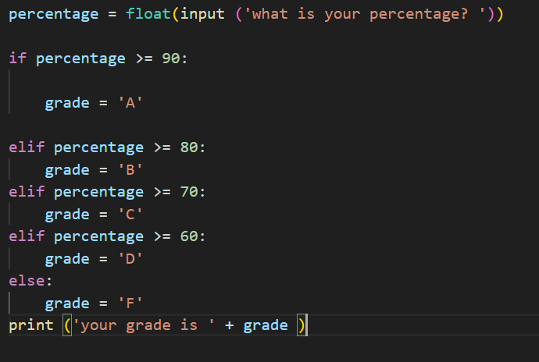

**OUTPUT:**

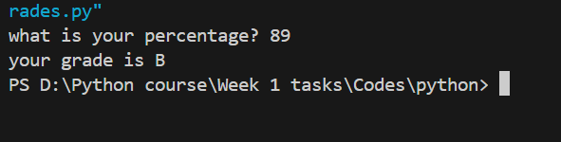

**LEARNED:**

I learned how to use multiple elif conditions to check ranges, store a result in a variable, and print a message with that result. It’s a clean way to handle grading logic.

**TASK NO:6**

**STEP BY STEP:**

1. I entered my name, age, and email using input().

2. Python stored each input as a string.

3. It joined all the information using + to make a single message.

4. It printed a greeting with my details.

**CODE:**

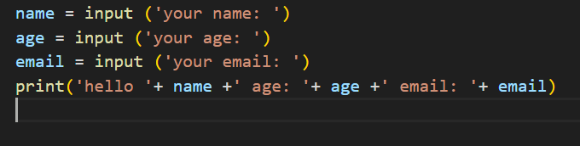

**OUTPUT:**

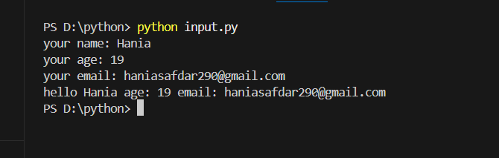

**LEARNED:**

I learned how to take multiple inputs, store them in variables, and combine them into a sentence using string concatenation with +.

**TASK NO:7**

**STEP BY STEP:**

1. I entered the investment amount, interest rate, and time.

2. Python converted all inputs to float for decimal calculations.

3. It calculated simple interest using the formula: (P × R × T) / 100.

4. It printed the total interest with a message.

**CODE:**

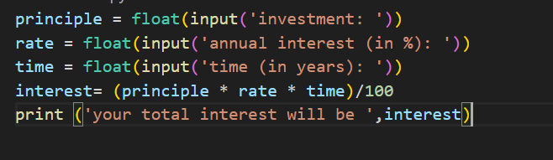

**OUTPUT:**

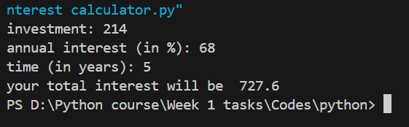

**LEARNED:**

I learned how to take multiple float inputs and use a math formula to calculate simple interest. I also practiced using print() to show the result clearly.

**TASK NO:8**

**STEP BY STEP:**

1. I entered a number of minutes using input() and converted it to float.

2. Python divided it by 60 to convert minutes to hours.

3. It printed the result with a message.

**CODE:**

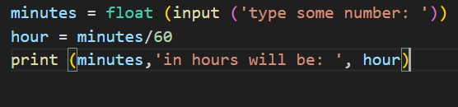

**OUTPUT:**

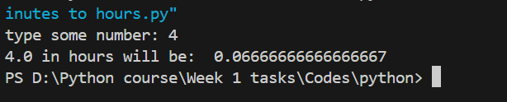

**LEARNED:**

I learned how to convert time from minutes to hours using division and how to show both input and output together using print().

**TASK NO:9**

**STEP BY STEP:**

1. I used print() to display a message.

2. It showed the text exactly as I wrote it.

**CODE:**

**OUTPUT:**

**LEARNED:**

I learned how to use print() to show simple output on the screen in Python.

**TASK NO:10**

**STEP BY STEP:**

1. I set a password using input().

2. Python checked each character in the password using a for loop.

3. It marked if there was an uppercase letter, lowercase letter, or a digit.

4. It added up how many types were present.

5. If the password was less than 6 characters, it printed "weak password".

6. If all 3 types were found, it printed "strong password", otherwise "weak password".

**CODE:**

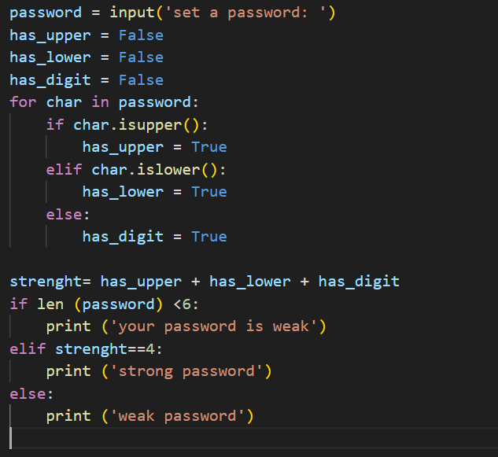

**OUTPUT:**

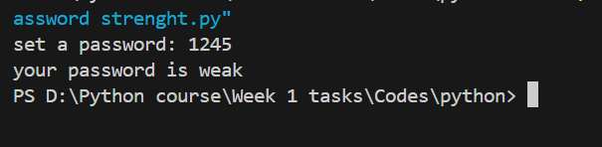

**LEARNED:**

I learned how to loop through a string, check character types using .isupper(), .islower(), and how to use boolean flags to measure password strength.

**TASK NO:11**

**STEP BY STEP:**

1. I entered two numbers using input() and converted them to integers.

2. Python checked if both numbers are divisible by 3 using %.

3. If they were, it added them and printed the sum.

4. If not, it printed a message saying they’re not divisible by 3.

**CODE:**

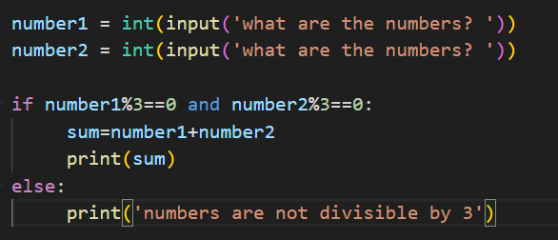

**OUTPUT:**

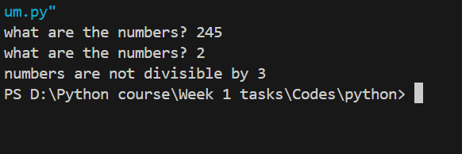

**LEARNED:**

I learned how to use the modulus operator to check divisibility, combine conditions using and, and control the output with if-else.

**TASK NO:12**

**STEP BY STEP:**

1. I entered a number using input() and converted it to an integer.

2. Python used a for loop with range(1,11) to repeat 10 times.

3. In each loop, it multiplied the number by the current value of i.

4. It printed the multiplication in a proper table format.

**CODE:**

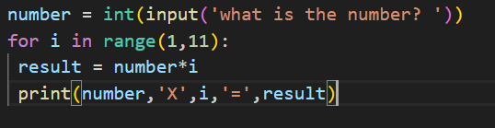

**OUTPUT:**

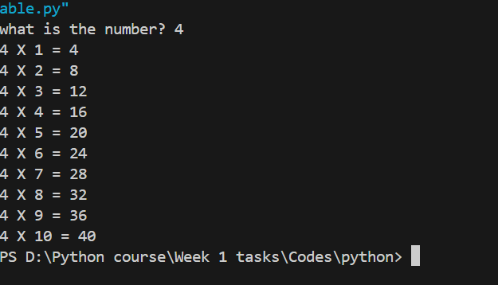

**LEARNED:**

I learned how to use a for loop with range() to create a multiplication table and how to print formatted results using multiple values in print().

**TASK NO:13**

**STEP BY STEP:**

1. I entered my full name using input().

2. Python used .strip() to remove extra spaces and .split() to break the name into parts.

3. If there were at least two parts, it created a username like firstname.lastname.

4. If there was only one part, it used just that as the username.

5. It printed the final username.

**CODE:**

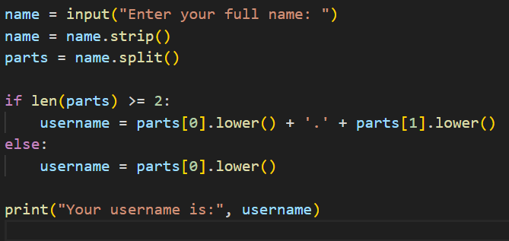

**OUTPUT:**

**LEARNED:**

I learned how to clean input with .strip(), split text with .split(), and build a custom string using conditions and .lower().

**TASK NO:14**

**STEP BY STEP:**

1. I set a to 2 and b to 6.

2. Python swapped the values using a, b = b, a.

3. It printed the new values of a and b.

**CODE:**

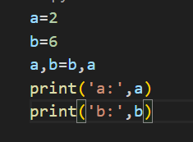

**OUTPUT:**

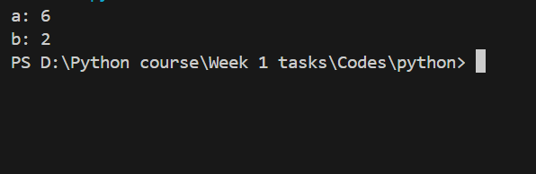

**LEARNED:**

I learned how to swap two variables in Python without using a temporary variable. It’s simpler than

**TASK NO:15**

**STEP BY STEP:**

1. I entered some text, and Python converted it to lowercase and removed extra spaces.

2. It used a for loop to go through each character.

3. It checked if the character is a letter using .isalpha().

4. If it was a vowel, it added to vowel_count; otherwise, to consonant_count.

5. It printed the total number of vowels and consonants.

**CODE:**

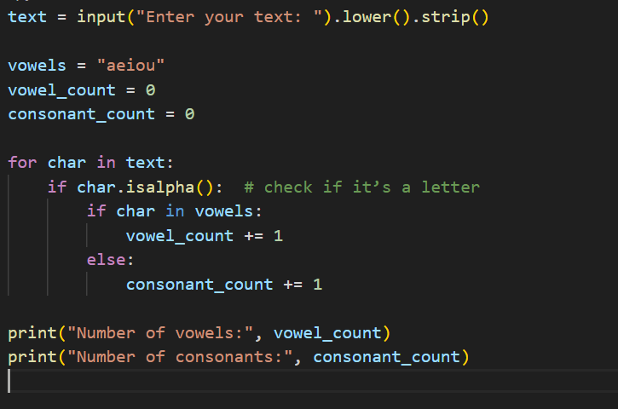

**OUTPUT:**

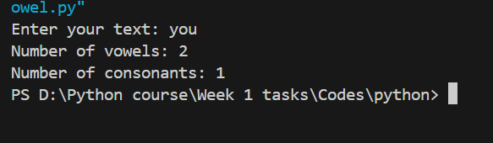

**LEARNED:**

I learned how to clean and analyze text using .lower(), .strip(), and .isalpha(), and how to count specific characters with a loop and conditions.